N Just-
spring when the world is mud-
luscious the little
lame baloonman
whistles far and wee

and eddieandbill come
running from marbles and
piracies and it's
spring

when the world is puddle-wonderful
the queer
old baloonman whistles
far and wee
and bettyandisbel come dancing
from hop-scotch and jump-rope and
it's
spring
and
the
goat-footed
baloonMan whistles
far
and
wee
~~~~~by: e e cummings (1894-1962)
Read the poem aloud twice (2 different readers)
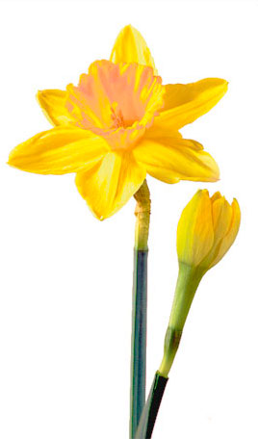
What puzzles you?
What words convey the tone?
What is the overall tone?
What image(s) come to your mind?
What is the central idea?
Does this image here on the right suit this poem? (Words and Images)

