STAGE 1 – DESIRED RESULTS

Grade Level: 4
Unit Title: Creative Writing through Writer’s Workshop

Established Goals: Use the writing process to develop a creative writing piece with strong lead, sequencing, figurative language, striking word choice, and conclusion.

For one month, students will participate in writer’s workshop 2 times a week to learn how to start, draft, revise, edit, and publish a creative narrative that includes an engaging lead, organized sequencing of events, examples of figurative language, vivid verbs, spicy adjectives, and a clear ending.

Understandings  Students will understand the qualities of creative narrative writing and be able to use these techniques in their own writing.  Students will understand the writing process. | Essential Question  How does creative writing capture the reader’s interest?  What does a writer need to include in a creative narrative to keep a reader interested?

Common Core Standards
Texts, Types, & Purposes
Grade 4, Standard 3. Write narratives to develop real or imagined experiences or events using effective technique, descriptive details, and clear event sequences.
a. Orient the reader by establishing a situation and introducing a narrator and/or characters; organize an event sequence that unfolds naturally.
b. Use dialogue and description to develop experiences and events or show the responses of characters to situations.
c. Use a variety of transitional words and phrases to manage the sequence of events.
d. Use concrete words and phrases and sensory details to convey experiences and events precisely.
e. Provide a conclusion that follows from the narrated experiences or events.

- MA.3.A Write stories, poems, and scripts that use similes and/or metaphors.

Production & Distribution of Writing
4. Produce clear and coherent writing in which the development and organization are appropriate to task, purpose, and audience. (Grade-specific expectations for writing types are defined in standards 1–3 above.)
5. With guidance and support from peers and adults, develop and strengthen writing as needed by planning, revising, and editing.

STAGE 2 – ASSESSMENT EVIDENCE

Performance Task  - Final writing piece demonstrating writing process and key writing elements.  - The teacher will meet with students weekly to conference about their writing and to assess each student’s progress.  - The teacher will keep a running record of student/teacher conferences. | Other Evidence:  - The students will pick one piece of writing to publish at the end of one month. This piece will be scored according to the rubric for creative narrative writing.  - Daily Writer’s Workshop assessment rubric

STAGE 3 – LEARNING PLAN
Summary of Learning Activities
- Each child will receive a composition notebook with a list of creative writing prompts glued onto the front cover.
- Students will decorate the cover of their notebooks using magazine clippings to create a collage that represents their unique personalities.
- 10 mini lesson topics will be placed in a basket. (Corresponding definitions and examples will be available for students to paste inside their notebooks).
- Students will select clock buddies. (Their clock buddies will be pasted on the back page of their notebook).
- At the beginning of each Writing period, one student randomly selects a topic to be covered in a mini lesson. These topics include: personification; metaphor; simile; idiom; hyperbole; using quotation marks; compound words; spicy adjectives; vivid verbs; show don’t tell etc.
- Each child will glue the definition of the selected mini lesson topic into their notebooks and the instructor will use prepared Smartboard lessons to review the chosen skill. (Students may take additional notes as needed).
- Students will then select or formulate their own creative writing prompt to respond to for 20 minutes. (They must include AT LEAST 3 examples of the mini lesson skill to demonstrate understanding).
- After students write for 20 minutes, they will meet with their selected clock buddy to share their stories and provide two compliments and one constructive criticism on sticky notes.
- At the next Writing class, students may choose to continue writing the story they started the previous day or begin a new story.
- Repeat for 4 weeks.
- At the end of the month, students will select their favorite story to revise, edit, and publish.
- Students will first FINISH the story, then revise and edit independently using a checklist.
- Students will then conference with a peer using the peer editing checklist.
- Next, students will conference with the classroom teacher and/or instructional assistant to revise and edit their writing piece.
- Finally, Students will publish a final draft.

Active learning strategies
- The students will spend most of writing workshop each day writing in their journals and incorporating the techniques/skills reviewed in the daily mini-lesson.
- Writers will use feedback from their clock buddies to revise their work.

Differentiation
- Struggling writers will have sentence starters and a word wall to assist them.
- Students who struggle with organizing their ideas will be given a 4 square organizer to assist them.
- ALL students will be provided with written definitions and examples to refer to within their writing journal.
- Students will use checklists and rubrics for revising and editing their own work.
- Clock buddies are heterogeneously partnered.

Re-teach if necessary

- The teacher/IA will devote more time to conferencing with struggling writers.
- The teacher/IA will check in with struggling writers after a mini-lesson
- The teacher with provide struggling writers with checklists, rubrics, and graphic organizers to help keep them and their writing focused.

Creative Writing Prompts for Writer’s Workshop

1. Imagine you had a hundred dollars, but you couldn't keep it. You had to give it away to a person or charity. Who would you give it to? What would you want them to do with it?
2. Describe one time when you were brave.
3. If you could cook any meal for your family, what would you cook? Describe the meal and tell how you would make it.
4. Imagine you woke up and saw a dinosaur in your backyard. Write a story telling what you see and do.
5. Imagine you opened your own restaurant. Tell the name of your restaurant. Explain what the restaurant looks like, who works there, and what you serve.
6. Describe your favorite character from a book, a movie, or television.
7. Write a story titled, "My Journey on a Pirate Ship." You and your friends can star in the story.
8. If you could have any animal for a pet, what would it be? Describe the pet and how you would take care of it.
9. Write a story about eating lunch with someone famous.
10. Write a story titled, "The Bat Who Couldn't Fly."
11. Write a story about having an unusual pet.
12. Imagine you worked at a football stadium. What would your job be? (Examples: quarterback, cheerleader, coach, referee, ticket seller) Describe what you would do while you were on the job.
13. What do you like best about your home?
14. Write a story titled, "The Baby Dragon."
15. Write a story as if you were a student in Mrs. Frizzle’s class on the Magic School Bus.
16. Imagine you woke up with a superpower. Describe your day!
17. Imagine you were twenty feet tall. Describe what life would be like.

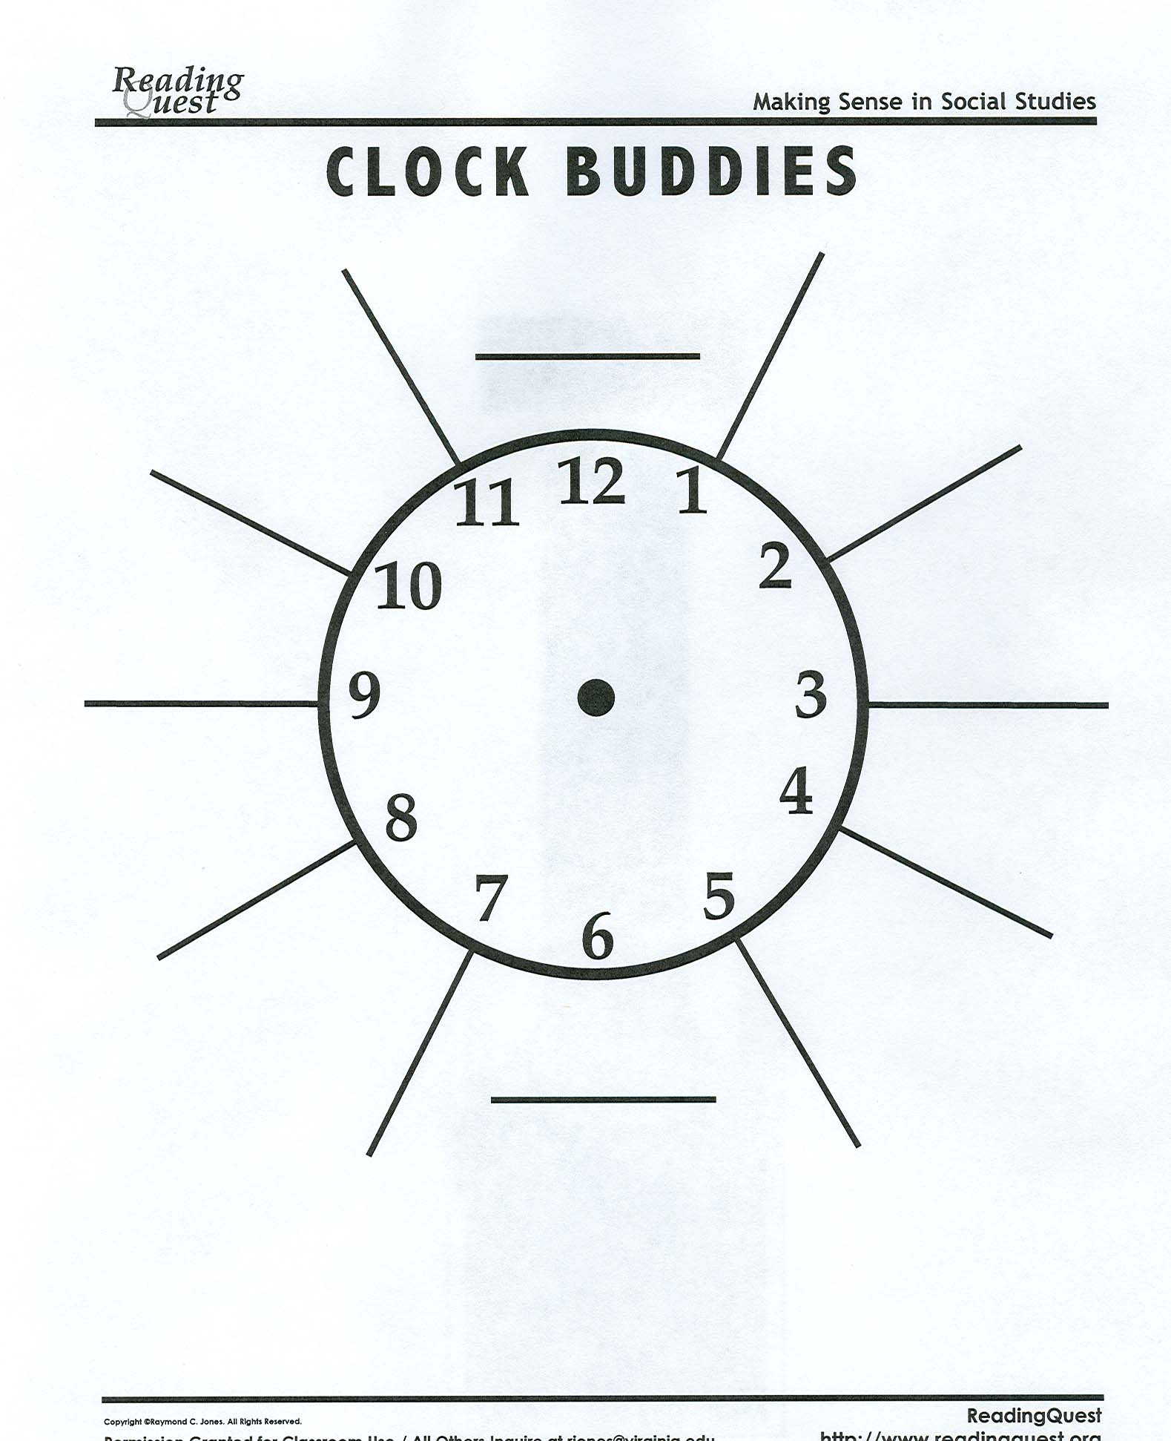

Additional Resources for Struggling Writers
4 Square Writing Template
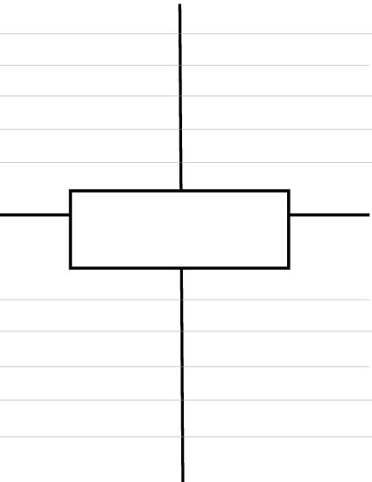
Name: ______________________________ Date: _______________________________
Editor’s Name: ______________________ Writing Assignment: ___________________
At first glance:
 | Yes | No | Comments
Did your partner skip lines?

Does your partner have appropriate spacing?
(indent, skip lines, space between words)

Lead
 | Yes | No | Comments
Did your partner include a hook?
Did your partner include example(s) of figurative language? (metaphor; simile; personification etc)

Body Paragraph #1
 | Yes | No | Comments
Did your partner include a subtle transition?
Did your partner include 3+ sequential details?
Did your partner “SHOW” not “tell”?
Did your partner include example(s) of figurative language? (metaphor; simile; personification etc)

Body Paragraph #2
 | Yes | No | Comments
Did your partner include a subtle transition?
Did your partner include 3+ sequential details?
Did your partner “SHOW” not “tell”?
Did your partner include example(s) of figurative language? (metaphor; simile; personification etc)

Body Paragraph #3
 | Yes | No | Comments
Did your partner include a subtle transition?
Did your partner include 3+ sequential details?
Did your partner “SHOW” not “tell”?
Did your partner include example(s) of figurative language? (metaphor; simile; personification etc)

Conclusion/Ending
 | Yes | No | Comments
Did your partner have a clear ending for their story?

Mechanics and Voice
 | Yes | No | Comments
Are there AT LEAST 5 spicy adjectives?
Are there AT LEAST 6 DIFFERENT transition words?
Are there more than 3 words spelled incorrectly?
Is there AT LEAST 5 examples of figurative language? (metaphor; simile; personification etc)
Are proper nouns and sentence starters the ONLY words that are capitalized?
Are appropriate end marks used throughout?
(period, comma, quotations etc)

Editor’s Signature: ____________________________ Date: ___________________

Please see Transition Words below

TRANSITION WORDS
Words that can be used to show time:
while | first | meanwhile | soon | then
after | second | today | later | next
at | third | tomorrow | afterward | as soon as
before | now | next week | about | when suddenly
during | until | yesterday | finally
Word that can be used to compare two things:
likewise | also | while | in the same way
like | as | similarly
Words that can be used to contrast two things:
but | still | although | on the other hand
however | yet | otherwise | even though
Words that can be used to emphasize a point:
again | truly | especially | for this reason
to repeat | in fact | to emphasize
Words that can be used to conclude or summarize:
finally | as a result | to sum up | in conclusion
lastly | therefore | all in all | because
Words that can be used to add information:
again | another | for instance | for example
also | and | moreover | additionally
as well | besides | along with | other
next | finally | in addition
Words that can be used to clarify:
that is | for instance | in other words

Spicy Adjectives | Vivid Verbs
sparkling  rancid  gorgeous  enormous  delicious  attractive  incredible  anxious  fiery  fierce  generous  honest  jealous  pleasant  perfect  exhausted  humorous  dangerous  curious  breathless  drowsy | slammed  darted  charged  sauntered  danced  tiptoed  sprinted  obtained  leaped  raced  purchased

Please see Figures of Speech below

Definitions for Student Notebook

Simile
A simile uses the words “like” or “as” to compare one object or
idea with another to suggest they are alike.
Example: busy as a bee

Metaphors
The metaphor states a fact or draws a verbal picture by the use of comparison.
A metaphor makes a direct comparison - it says you are something.
Example: You are what you eat.

Personification
A figure of speech in which human characteristics are
given to an animal or an object.
Example: My teddy bear gave me a hug.

Alliteration
The repetition of the same initial letter, sound, or group of sounds in a series
of words. Alliteration includes tongue twisters.
Example: She sells seashells by the seashore.

Onomatopoeia
The use of a word to describe or imitate a natural sound
or the sound made by an object or an action.
Example: snap, crackle, pop

Hyperbole
An exaggeration that is so dramatic that no one would believe the
statement is true. Tall tales are hyperboles.
Example: He was so hungry, he ate that whole
cornfield for lunch, stalks and all.

Idioms
An expression whose meaning is not predictable from
the usual meanings of the actual words.
Example: I have a frog in my throat.

Quotation Mark Rules:

Rule 1
Periods and commas always go inside quotation marks, even inside single quotes.
Example: She yelled, "Hurry up."
“I think I’ll eat a cupcake,” stated Sophie.

Rule 2
The placement of question marks with quotes follows logic. If a question is in quotation marks, the question mark should be placed inside the quotation marks.
Example: She asked, "Will you still be my friend?"

Compound Words
Did you know that there are three different types of compound words?
Closed form: Two words are joined together to create a new meaning. EXAMPLES: firefly, softball, redhead, keyboard, makeup, notebook.
Hyphenated form: The words are joined together by a hyphen. EXAMPLES: daughter-in-law, over-the-counter, six-year-old.
Open form: The words are open but when read together, a new meaning is formed. EXAMPLES: post office, real estate, full moon, half sister.

Please see Revision and Editing Guide below

Independent Checklist(s)
REVISING v. EDITING
INCLUDEPICTURE "http://media-cache-lt0.pinterest.com/550x/0e/30/de/0e30de878ef4dd50c0e702d50d35c6b8.jpg" \* MERGEFORMATINET 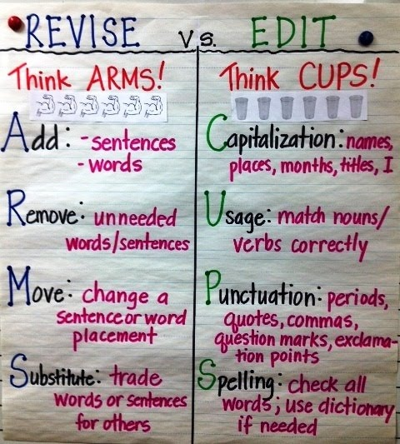

ARMS Activity - Revising
Name: _________________________________ Date: ____________________

Directions: Choose 1 paragraph from your sloppy copy. Edit the paragraph using ARMS. Rewrite paragraph on lined piece of paper – DO NOT skip lines.

Add:
- SHOWING sentences
- Words – spicy adjectives/vivid verbs
- Dialogue

Remove:
- Unneeded words/sentences
- Ideas that do not make sense

Move:
- Change a sentence or word placement

Substitute:
- Trade words or sentences for others ex: gets & gots
- Substitute “DEAD” adjectives or verbs with synonyms

CUPS ACTVITIY (Editing)
Name: ____________________________ Date: _________________

Directions: Choose 1 paragraph from your sloppy copy. Edit the paragraph using CUPS. Rewrite paragraph on lined piece of paper – DO NOT skip lines.

Capitalization:
- Sentence starters
- Proper nouns (names of people, places, or things ex: Walmart; Mrs. Vaillancourt; Millbury)

Uses:
- Same tense is used throughout (past tense)
  - Example: I go to the store. CHANGE to I went to the store.
- Subject- Verb Agreement
  - Mrs. Vaillancourt like chocolate. CHANGE to Mrs. Vaillancourt likes chocolate.

Punctuation:
- All sentences have end marks
- Check your use of dialogue (refer to your quotation mark guidelines)

Spelling:
- Use a dictionary to look up how to spell difficult words
- Re-read CAREFULLY for write – o’s

RUBRIC
Daily Reflection for Writer’s Workshop Notebook
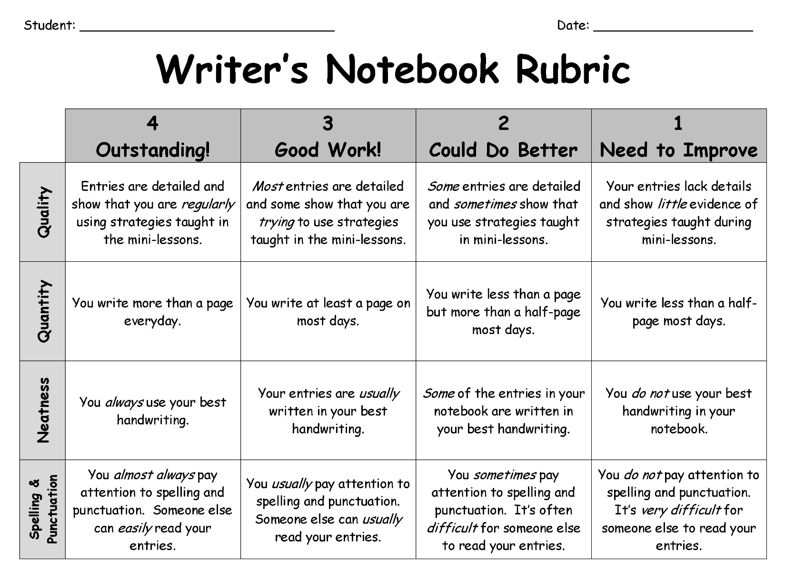

Final Rubric for Assessing

6 Awesome! | 5 Strong! | 4 Good!
- Catchy Title  - Entertaining lead with 3+ examples of figurative language  - A lot of spicy adjectives and vivid verbs  - SHOWING not TELLING sentences  - Effective use of dialogue  - Clear conclusion  - Excellent command of conventions  - Story flows well due to subtle transitions | - Fitting Title  - Entertaining lead with 2+ examples of figurative language  - Mostly SHOWING sentences  - Story flows well due to some subtle transitions  - Some use of spicy adjectives and vivid verbs  - Use of dialogue  - Conclusion brings story to an appropriate end  - Adequate use of conventions | - Title  - Interesting lead with >2 examples of figurative language  - Story contains SOME showing AND some telling sentences  - Story flows due to transitions (some subtle/some obvious)  - Some spicy adjectives and vivid verbs  - Use of dialogue  - Conclusion brings story to an end  - Some use of proper conventions
3 A few things to work on! | 2 You’re on your way! | 1 Let’s discuss this!
- Title  - Basic story with some details  - Contains a lead with at least 1 example of figurative language  - Story contains many telling sentences  - Has some obvious transitions, but story doesn’t flow well  - Few spicy adjectives and vivid verbs  - Little or incorrect use of dialogue  - Abrupt ending  - Some use of conventions | - Simple or missing title  - Basic story – lacking details  - Events not all in logical order  - Story does not flow.  - Reader has many questions  - List-like, without details, dull  - No dialogue  - No real ending  - Poor use of conventions | - Simple or missing title  - Not a full story with missing details  - Lacks organization, events out of order  - Reader is confused  - Simple language  - No dialogue  - No ending  - Weak use of conventions

* I modified this rubric based on Wiggins/McTighe Rubric
OFFICIAL MCAS LONG COMPOSITION RUBRIC

Scoring Guides for MCAS English Language Arts Composition

Scoring Guide for Topic/Idea Development
Score | Description
6 | - Rich topic/idea development  - Careful and/or subtle organization  - Effective/rich use of language
5 | - Full topic/idea development  - Logical organization  - Strong details  - Appropriate use of language
4 | - Moderate topic/idea development and organization  - Adequate, relevant details  - Some variety in language
3 | - Rudimentary topic/idea development and/or organization  - Basic supporting details  - Simplistic language
2 | - Limited or weak topic/idea development, organization, and/or details  - Limited awareness of audience and/or task
1 | - Little topic/idea development, organization, and/or details  - Little or no awareness of audience and/or task

Scoring Guide for Standard English Conventions
Score | Description
4 | - Control of sentence structure, grammar and usage, and mechanics (length and complexity of essay provide opportunity for student to show control of standard English conventions)
3 | - Errors do not interfere with communication and/or  - Few errors relative to length of essay or complexity of sentence structure, grammar and usage, and mechanics
2 | - Errors interfere somewhat with communication and/or  - Too many errors relative to the length of the essay or complexity of sentence structure, grammar and usage, and mechanics
1 | - Errors seriously interfere with communication AND  - Little control of sentence structure, grammar and usage, and mechanics

