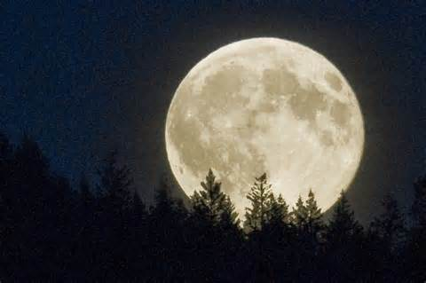 Harvest Moon
Drowsy after a day of carnival fun,
Rocked gently homeward in the car,
I have almost fallen asleep
when the moon rises like a dream
outside my back-seat window.
It is the world’s largest Ferris wheel,
bright as a beacon,
welcoming all riders.
It is a giant pumpkin slowly ripening,
Outgrowing its protective ground cover.
It is the face of a smiling friend
who wants to play hide-and-seek
behind the highway’s bare trees.
I smile back at my friend
And drift off to sleep.
Maybe I’ll play when I awaken.

Highlight similes in yellow, highlight metaphors in turquoise. How do these add to meaning?

