Author Kay Scheidler accentuates the positive about Common Core
- News
by Janet Hefler - Apr 23, 2015
1
Uniform learning standards level the playing field for all students.
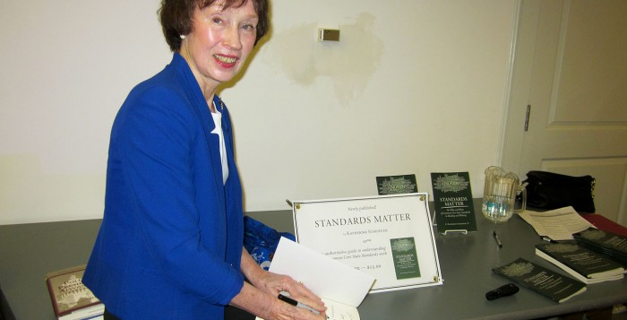Katherine Scheidler signed copies of her book, "Standards Matter," following her presentation about Common Core state education standards at the Vineyard Haven Public Library on April 4. – Photo by Janet Hefler
Common Core State Standards are getting an undeserved bad rap, Katherine (Kay) Scheidler, author of a new book, Standards Matter, said. Ms. Scheidler spoke out in support of the high-quality learning associated with the standards, and dispelled what she said are some of the misconceptions at a book talk and signing on April 4 at the Vineyard Haven Public Library.
State education leaders and governors in 48 states worked together to develop the Common Core, a set of standards, not curriculum, in English language arts and literacy and mathematics. Ms. Scheidler’s book focuses on “the why and what of Common Core State Standards in reading and writing.”
The standards spell out the reading and math skills students should acquire, grade by grade, as they progress from kindergarten through high school. Common Core standards were designed as a set of uniform benchmarks to ensure that high school graduates from any state will learn the same skills and be ready to begin college without needing to take remedial classes.
Although state adoption of the standards is not mandatory, currently 43 states have voluntarily adopted them and are working to implement them. The Massachusetts Board of Elementary and Secondary Education adopted the Common Core standards in July 2010, and they became part of the state curriculum in 2011.

Leveling the playing field
The idea that common learning standards for all children are key to educational equity and fairness took root early in Ms. Scheidler’s teaching career. She said that tracking, the practice of grouping students by achievement level, was the norm when she started her first job as a student teacher at Hope High School in Providence in 1969. It was then she realized that having different standards for students of different levels was detrimental to those who weren’t at the top.
“The inequity of the top-track kids getting the best of education and the kids in the lower levels not getting the same quality of education has an awful lot to do with what Common Core standards are,” Ms. Scheidler said. “It’s a matter of taking the top-level kind of expectations and trying to get all kids to move to that level for equity and fairness.”
She takes issue with critics who argue that Common Core standards may “dumb down” learning for top-level students.
“The goal is really to take high-level standards and help kids grow to that level,” Ms. Scheidler said. “Instead of teaching and then giving a test that some kids pass and some kids don’t pass, it’s the idea of setting out and making it clear to kids what you want them to learn and trying to bring them up to that level.”
Ms. Scheidler discussed examples of high-level English projects she has observed and the Common Core standards that students learned, which included expository/argumentative writing; reading nonfiction text for information; evaluating visuals and text; reading complex text proficiently; producing clear and coherent writing; and engaging in peer review, revisions, and research. Common Core standards require that students use online and print sources, and document them, she added.

How Common Core evolved
Ms. Scheidler said that the move to establish education standards started in 1983, following a report from a national commission that cited “a rising tide of mediocrity” in its study of American schools. It came as a wake-up call to state governors and state commissioners of education, which led to a pledge by the governors in 1989 to establish standards and assessment tests in common.
In 2002, President George Bush signed the No Child Left Behind (NCLB) Act into law. It garnered criticism from many educators and lawmakers, who deemed the law’s requirement that all students be proficient in reading and math by 2014 as unrealistic.

Changes in testing
Massachusetts is also in the middle of a two-year trial of the Partnership for Assessment of Readiness for College and Careers (PARCC) tests in English language arts (ELA) and mathematics, under consideration as a replacement for Massachusetts Comprehensive Assessment System (MCAS) exams.
Last spring Edgartown School, Tisbury School, West Tisbury School, and Martha’s Vineyard Regional High School took part in field tests of the new PARCC tests online. Oak Bluffs School and the Martha’s Vineyard Public Charter School used paper tests.
“When I first looked at MCAS tests, and saw what was expected in 10th grade, which was that every student was supposed to be able to take a piece of literature they read and write a literary analysis paper on it, I thought, Oh, wouldn’t it be wonderful if every student could do that?” Ms. Scheidler said. “We didn’t quite get every student to proficient, which was the goal under No Child Left Behind by 2014, but we’ve moved kids along tremendously, just by having these standards and the vision. With Common Core, the standards are a bit more stringent and the tests a bit harder, but basically it’s the same idea.”

Common Core and PARCC protests
Common Core standards recently have become a hot-button topic in the looming 2016 presidential race, Ms. Scheidler noted. Some critics on the political right are denouncing Common Core as representing a federal takeover of school curriculum, which she said is false, because the state-led initiative leaves curriculum decisions under state and local control.
The standards are, however, technically tied to federal money. A competitive grant program for schools, the Race to the Top Fund (RTTF), was funded by the U.S. Department of Education through the American Recovery and Reinvestment Act of 2009. President Barack Obama linked RTTF grant money to states’ adoption of higher academic standards, without naming Common Core specifically.
As one of 12 winning states in the RTTF program, Massachusetts received a grant of $250 million to promote reform in the K-12 education system’s standards and assessment, teachers, and leaders, school improvement, and data systems. Island school districts in Edgartown, Oak Bluffs, and Tisbury, as well as the high school and Up-Island regional districts, applied for and received RTFF allocations totaling $118,129 over four years.
In the backdrop of political debate over Common Core are widespread protests in several states, which started in March, against the standards-aligned tests created by the PARCC consortium.
“The PARCC tests that are happening right now in the Vineyard schools are really assessments,” Ms. Scheidler said. “They’re not standardized tests like the old IQ tests or Iowa tests, where a test comes in from nowhere just to sort of peg a kid. They’re called criterion-reference tests, and you set a standard, and let the public know, the kids know, and the teachers know that, and what you’re teaching it for. It’s a way to assess where kids are, and to use that information to bring them along.”
Unfortunately, that difference has not been well-publicized, Ms. Scheidler said. Over the past few months, a huge opt-out movement against the tests has been promoted in several states on social media and on websites such as the Common Core Forum in Massachusetts.
“I haven’t gone to the website, because in a way, I don’t want to see it, because it hurts me enough to see negative things about the wonderful expectations and visionary Common Core standards and the assessments to help kids move along,” Ms. Scheidler said.
She concluded her presentation by answering questions from the small audience, which included several teachers, followed by a book signing.
As an adjunct instructor at Framingham State University, Ms. Scheidler teaches about understanding Common Core standards and their integration into curriculum and instruction. In addition to teaching at the high school and college level, her background includes 15 years as Massachusetts assistant superintendent for curriculum, instruction, and assessment, and also professional development, in Hopkinton and Canton. She holds a Ph.D. from Boston University’s School of Education, a graduate degree from the Harvard University Graduate School of Education, and a masters of arts in teaching English from the American University. Ms. Scheidler and her husband Peter are residents of Providence, R.I., and Vineyard Haven.
Standards Matter: The Why and What of Common Core Standards in Reading and Writing is available for $12.95 from the publisher, NewSouth and on Amazon

