N.Y. / Region

Some Parents Oppose Standardized Testing on Principle, but Not in Practice
By KYLE SPENCERAPRIL 13, 2015


This past winter, Nicholas Gottlieb, the father of a third grader and a sixth grader in Manhattan, helped organize a citywide forum against standardized testing during which more than 200 parents and teachers talked about ways to “attack the issue from different angles.”

Just last month, he led chants at a rally to protest Gov. Andrew M. Cuomo’s education platform, including a plan to make teacher evaluations more dependent on test scores.
But on Tuesday, when more than a million third through eighth graders in New York State sit for the first of six English and math testing sessions, Mr. Gottlieb’s two daughters, who attend Public School 3 in the West Village and the Clinton School for Writers and Artists in Chelsea, will be opting in.
“I would like to think that I would have the courage of my convictions,” he said. “But can I really do that when it means I’m gambling with my kids’ futures?”
New York has become a center of the nationwide anti-testing movement, and this could be a crucial year in determining whether it breaks out of the realm of rallies and Facebook pages to become a significant educational force. But for various reasons, even parents who are uncomfortable with the exams are discovering it is hard to push the button on the nuclear option — refusing to have their own children take them.

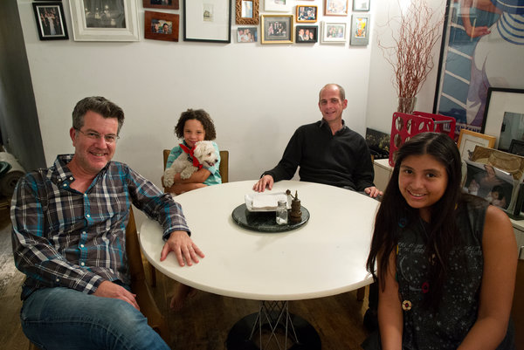
Nicholas Gottlieb, an anti-testing activist, left, with his husband, Macky Alston, and their daughters, Alice, right, and Penelope. Credit Victor J. Blue for The New York Times
David Michaelson, a biologist, and Joy Romanski, a climate scientist, recently attended a school rally with their son Jacob, a fifth grader at Public School 321 in Park Slope, Brooklyn, to protest the proposal of Mr. Cuomo, a Democrat, to make student test scores count for 50 percent of teacher ratings. (The bill that eventually passed allows the state’s Education Department to decide.)
But when it came time to decide whether Jacob would take the tests, Dr. Romanski said, “both of us knew that, no, we could not refuse.”
She and her husband want Jacob to take the test for Hunter College High School, a school for the gifted on the Upper East Side of Manhattan, which is offered to students who reach a high benchmark on the state tests.
The “opt-out” phenomenon began to grow a couple of years ago, when New York became one of the first states to switch to a tougher set of exams aligned with the Common Core curriculum standards. The state’s Education Department said it did not record how many students refused to take the standardized tests. But last year, of the estimated 1.1 million eligible test takers, roughly 49,000, or 4 percent, did not take the English exam and had no known valid reason, like an illness or an injury, for missing it. For math, the number was about 67,000, or 6 percent.
Test refusal has been more noticeable in suburban Long Island, where more than half of school district leaders reported opt-out rates of more than 10 percent last year, a survey of the Council of School Superintendents found.
But in New York City, where many students must apply to middle and high schools through a competitive process, the movement has been largely limited to a few progressive schools. Less than one-half of 1 percent of city students refused last year, according to the city’s Education Department.
Local anti-testing activists are seeking to change that.
In recent weeks, they have posted links to refusal letters on some school websites, held forums and circulated excerpts from interviews with middle school principals on how they handle applicants who have opted out, to indicate that for many schools, it would not be a penalizing factor in admissions. New York State Allies for Public Education, an opt-out group, has rolled out billboards and radio ads. And last week, New York State United Teachers, the statewide teachers’ union, began to robocall its members, denouncing what it called the governor’s “test and punish” agenda and telling parents in the union, “You have the right to opt your child out of state tests.”
Officials trying to stem the opt-out tide have also increased their communication.
“We don’t refuse to go to the doctor for an annual checkup,” Merryl H. Tisch, the chancellor of the State Board of Regents, told a meeting of superintendents last month. “Most of us don’t refuse to get a vaccination. We should not refuse to take the test.”
The New York City schools chancellor, Carmen Fariña, told principals in a recent letter that the tests provided value to “students, families, school staff and the city as a whole.” But she also encouraged them to respect parents’ decisions to opt out and to ensure that students had an alternative activity, such as independent reading, to engage in during the exams.
For some parents, like Kemala Karmen, opting out is a given. This will be the third year of no tests for her daughter Asha, an eighth grader at the Institute for Collaborative Education in Manhattan, and the second year for her daughter Talya, a fifth grader at the Brooklyn New School, both progressive schools with high test-refusal rates in recent years.
Ms. Karmen, the deputy director of a city nonprofit, charged that the math and English tests were age-inappropriate and had led, in many schools, to too much test preparation. She said she worried that the exams had squeezed out art and music instruction and the kind of “authentic learning” she favored.
Lilia Fung, the mother of an eighth grader at the New Exploration Into Science, Technology and Math School on the Lower East Side of Manhattan, might be considered a member of the quieter majority. Ms. Fung, a preschool teacher, said it was important for students to learn not to “freak out” when they faced standardized tests, so her daughter was taking them. The tests, she said, are a “useful diagnostic tool, among many others.”
Somewhere in between is Robin Sayetta. A branding and licensing consultant in Carroll Gardens, Brooklyn, Ms. Sayetta recently took advantage of the cancellation of her sons’ baseball games to have a Sunday-morning conversation with them in their living room. With her laptop out, she sorted through emails she had received from other parents, with documents attached including a letter signed by some of the city’s principals last year calling the tests “too long” and filled with “ambiguous questions.”
She also talked to her son Shane, a fifth grader, about reasons not to sit out the tests, including that he had already spent time preparing. She ultimately let her children decide, and Shane chose not to take them.
But her older son Luke, who begins the high school admissions process in the fall, will be opting in. “There’s just not a big opt-out movement at his middle school,” she said

