Teaching for Understanding Learning Plan

STAGE 1 – DESIRED RESULTS
Grade Level: 4
Unit Title: Revising and Editing Narrative Writing.
Established Goals:
This “mini-unit” will be taught once students have a first draft of a narrative writing piece completed. The goal of this mini-unit is to teach students to revise and edit their writing and to utilize peer editing to improve their final written piece. This mini-unit will be taught over 1 to 2 weeks.

Understandings:  Students will understand that an excellent piece of narrative writing requires many improvements, revisions, and edits and will strive to accomplish this in their work. | Essential Questions:  • Does this narrative piece include all the parts of the narrative diamond?  • Have I revised this piece to make it the best that it can be?  • Have I edited this piece so that it is grammatically correct?

Common Core Standards Mastered

Grade 4 Common Core Writing Standards:

Production and Distribution of Writing:

4. Produce clear and coherent writing in which the development and organization are appropriate to task, purpose, and audience.

5. With guidance and support from peers and adults, develop and strengthen writing as needed by planning, revising, and editing.

STAGE 2 – ASSESSMENT EVIDENCE
Performance Tasks:  Students will revise and edit a rough draft of a narrative writing piece that was previously written using the Empowering Writers “Comprehensive Narrative Writing Guide.”  Students will revise and edit their own piece and then use peer editing to continue to improve their own piece. | Other Evidence:  The final copy of the narrative writing piece will be evaluated using the attached narrative writing rubric based on Empowering Writers.

STAGE 3 – LEARNING PLAN
Summary of Learning Activities:

- Prior to the beginning of this mini-unit, the teacher will have taught the narrative writing process using the Empowering Writers Comprehensive Narrative Writing Guide. The students will have practiced writing each part of the narrative diamond individually and then put it all together to write a complete narrative piece. See Narrative Writing Diamond below.

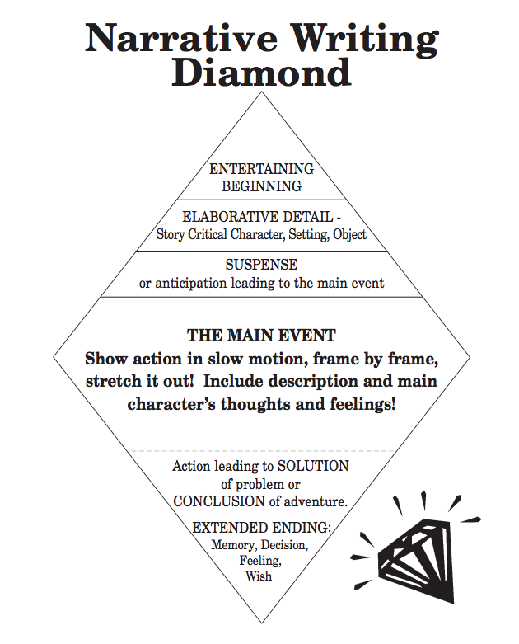

- Use the following Venn diagram to introduce the concept of revising and editing.

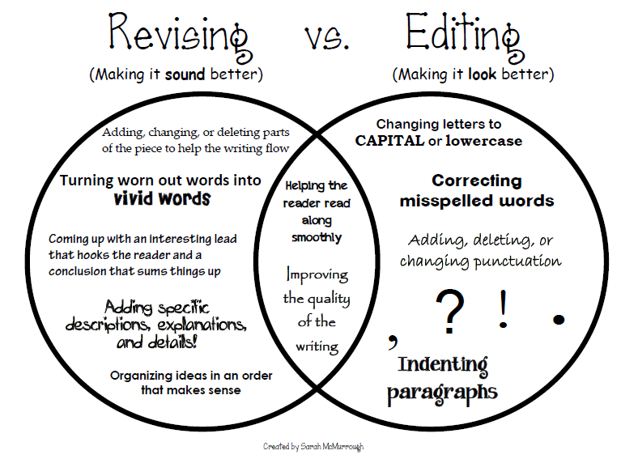

- Use the following ARMS visual to discuss and teach revising. See the separately attached “Revising and Editing with CUPS and ARMS” PDF file for the entire package from Teachers Pay Teachers.

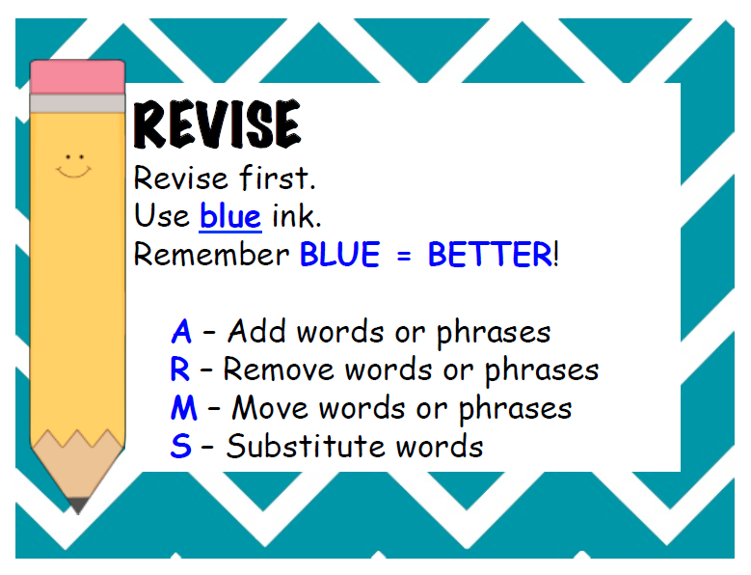

- Use the following visuals to model revising.

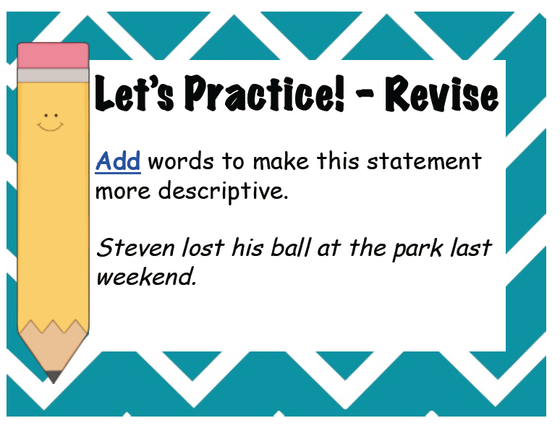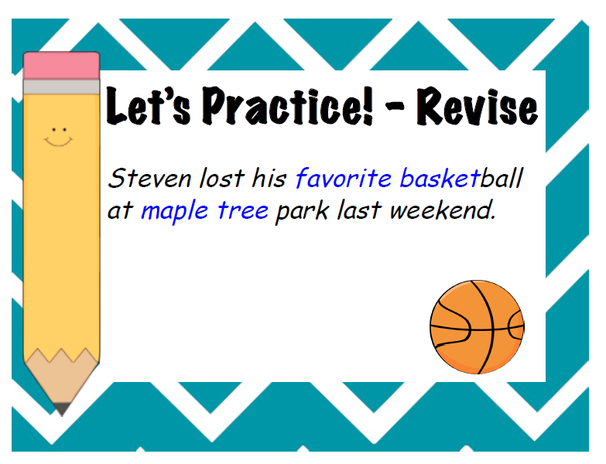

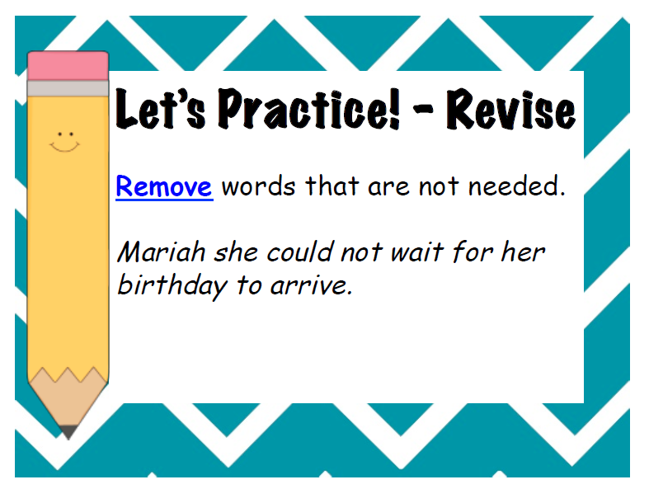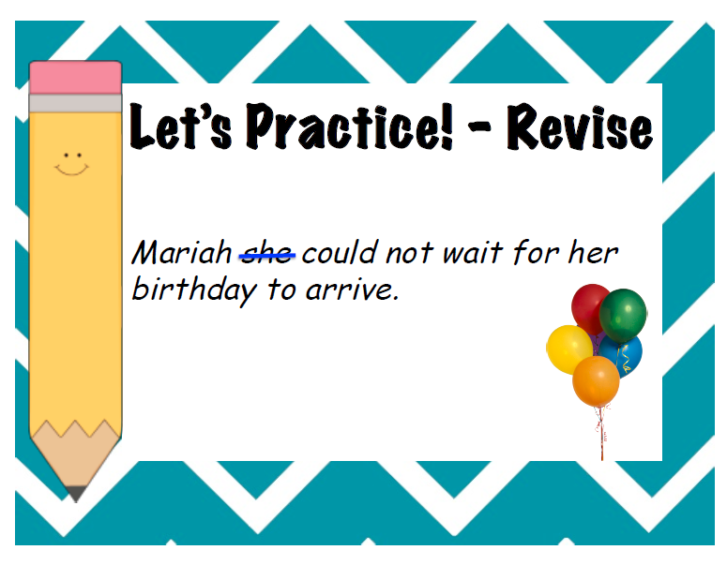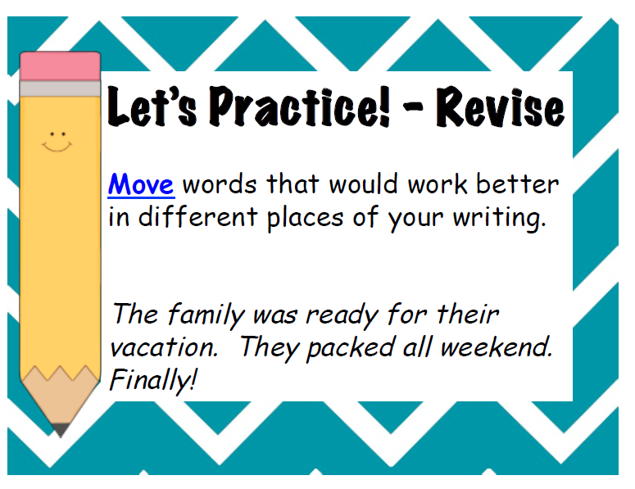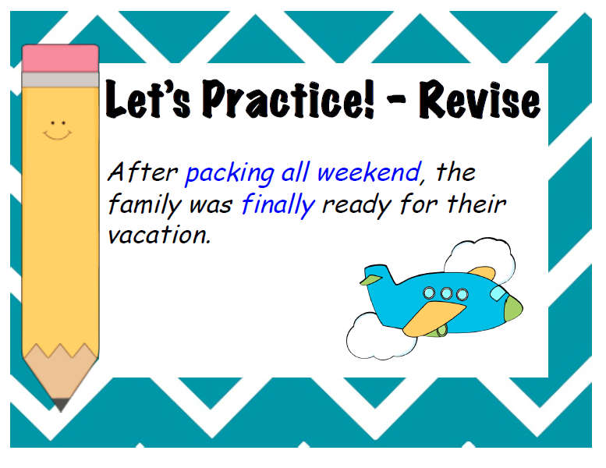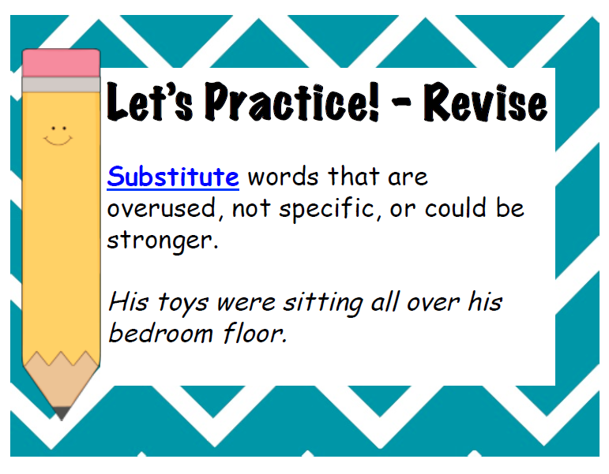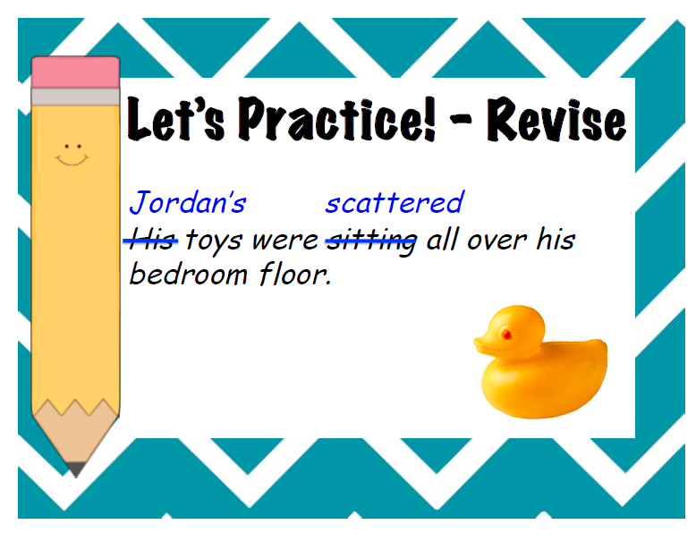

- Have students practice revising their own narrative piece using a blue pen to indicate revisions made.

- Use the following CUPS visual to discuss and teach editing. See the separately attached “Revising and Editing with CUPS and ARMS” PDF file for the entire package from Teachers Pay Teachers Use the following visuals to model editing.

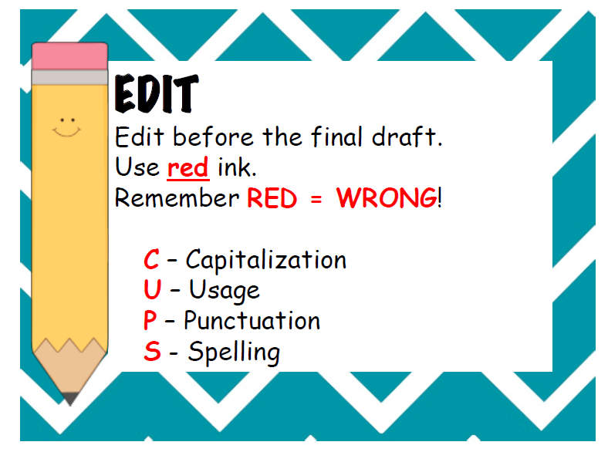

- Use the following visuals to model editing.

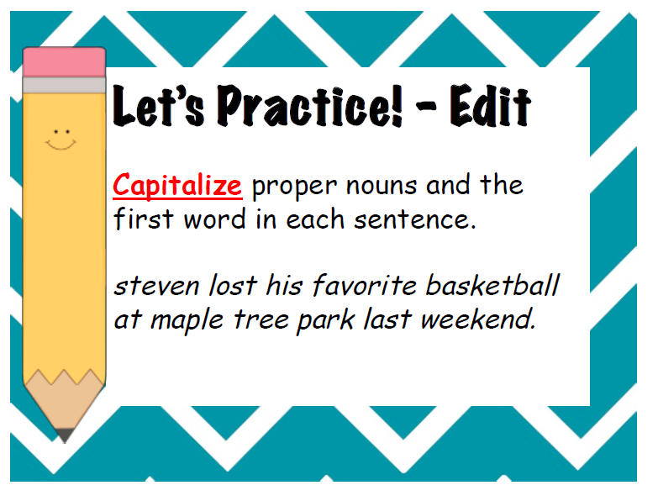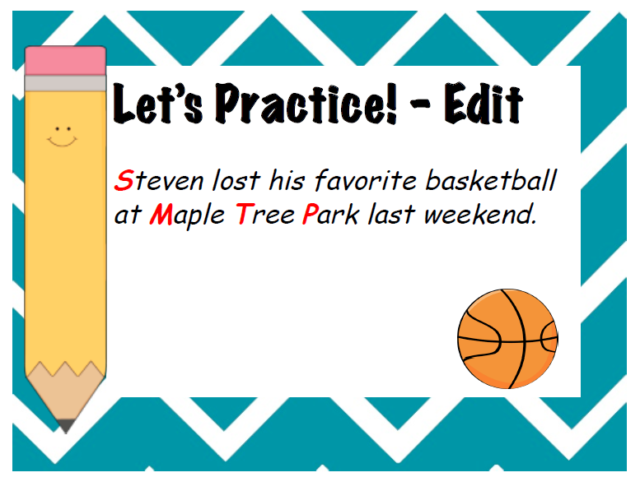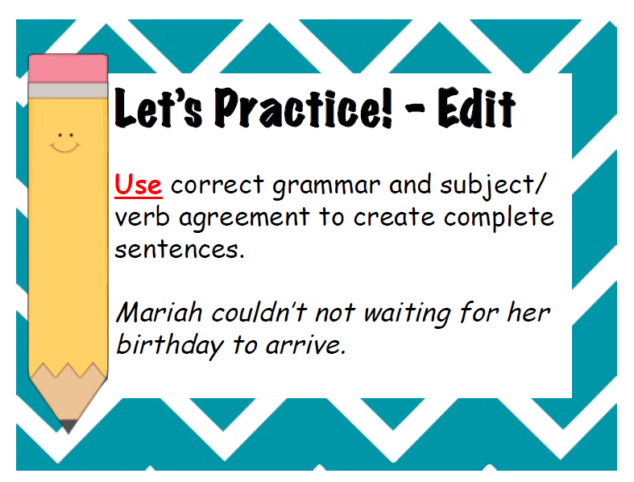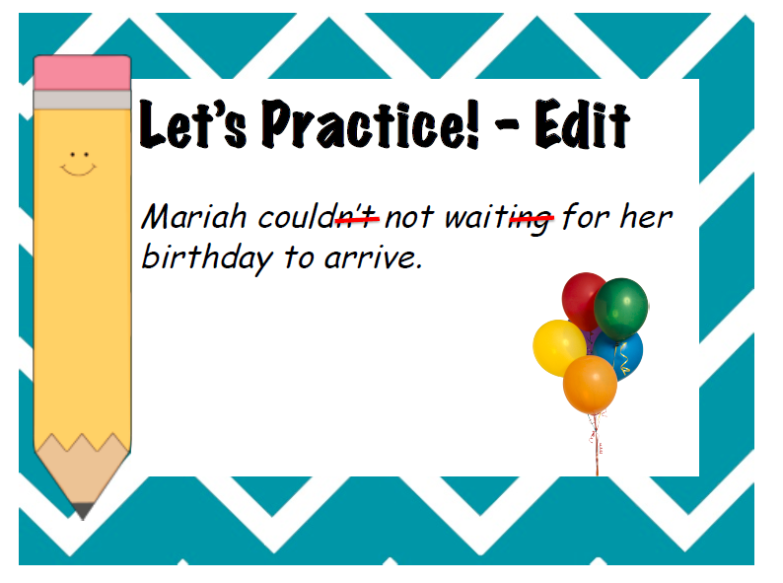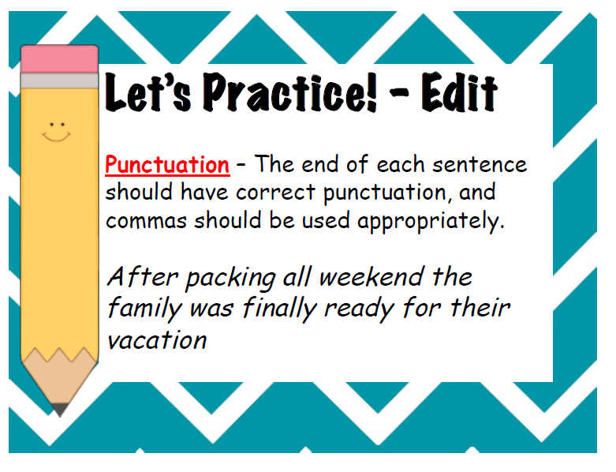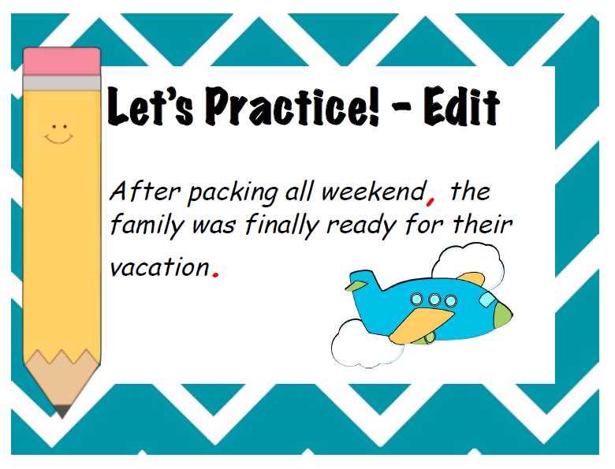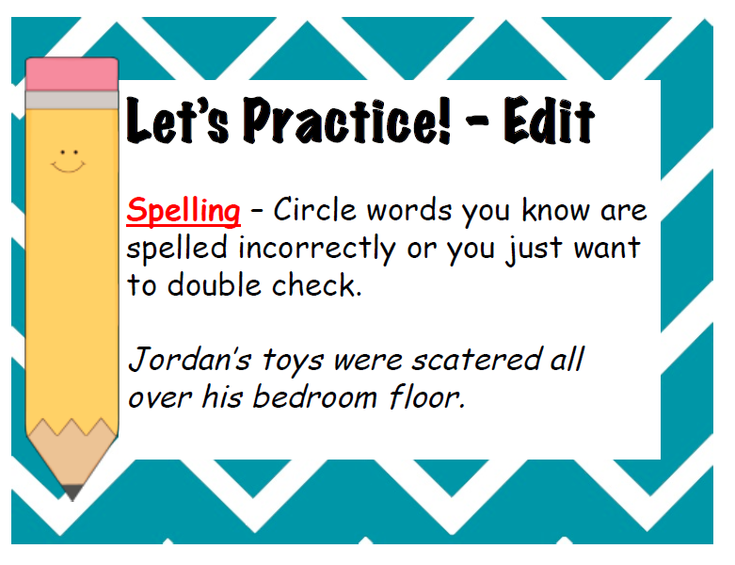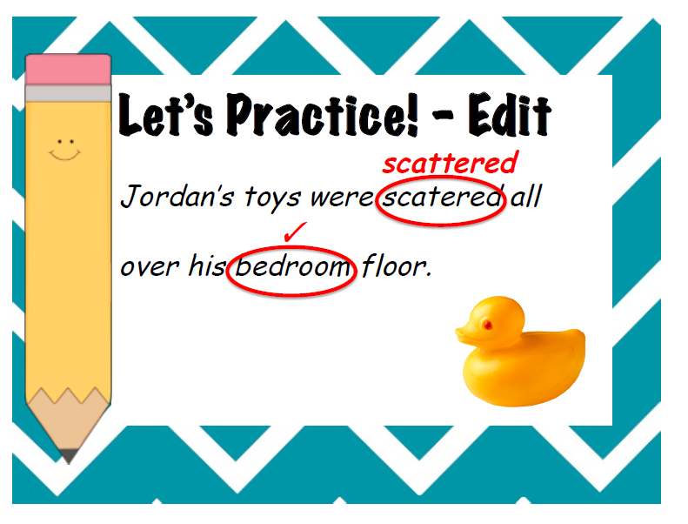

- Have students practice editing their own narrative piece using a red pen to indicate edits made.

- Students can use the following checklist as a visual to help them.

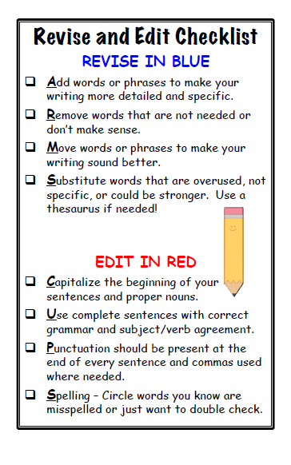

- Model peer editing of a narrative piece that has been revised and edited by the writer. Use the following documents from www.keystoliteracy.com to assist in the peer revising and editing process.

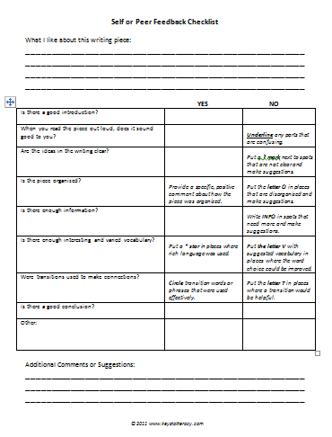

- Have students use peer editing worksheet to guide them in working together.

- Have students type their final product.

- Grade according to Empowering Writers Narrative Rubric.
Active Learning Strategies:

- Students will be actively working on revising and editing their own work throughout the learning process.
- Students will be working with a peer to assist in revising and editing each other’s work.

Differentiation:

- Teacher will work directly with the struggling writers while they are working on revising and editing their own pieces.
- Struggling writers will be grouped with peers that are patient and compassionate for peer editing.

Resources:

- Empowering Writers Comprehensive Narrative Writing Guide and www.empoweringwriters.com.
- Keys to Content Writing by Joan Sedita and www.keystoliteracy.com.
- www.teacherspayteachers.com/Store/Kristasuz for “Revising and Editing with CUPS and ARMS” PDF file.
- www.teacherspayteachers.com for “Revising vs. Editing” by Sarah McMurrough.

Re-Teaching
for students do not attain Proficient level in unit assessment

- Teacher will work with struggling students on revising and editing short samples of writing so that they can master the concept without struggling with their own writing.
- Teacher will work with struggling students on one concept at a time on short samples of writing so that the student who needs repetition to master a skill will gain that mastery.
- Each piece of the revising and then the editing process will be addressed individually.

Rubric to Guide and Assess Learning

Narrative Writing Rubric
(Based on Empowering Writers Narrative Rubric on empoweringwriters.com)

 | 4 – Exceeds Expectations | 3 – Meets Expectations | 2 – Making Progress | 1 – Not Meeting Expections
Organization | The response shows a tightly organized story that follows the diamond structure with a clear beginning, middle, and end.  The sequence of events unfolds naturally and it is easy to follow with a consistent use of a variety of transitional strategies. | The response has a beginning, middle, and end with evidence of the diamond structure.  The story sequence is loosely connected, with some transitional strategies evident. | The response shows a basic beginning, middle, and end.  The story is confusing in parts and often hard to follow. There are few if any transitional strategies evident. | The response shows no story sequence, with events unfolding in a random fashion, making it hard to follow.  There are no transitional strategies evident.
Entertaining Beginnings | The response begins with an entertaining beginning that uses a variety of strategies to establish the character(s), setting, and the story purpose.  The beginning draws the reader immediately into the story and compels the reader to read on. | The response begins with an entertaining beginning that uses a simple strategy to establish the character(s), setting and the story purpose.  The beginning is brief and may not compel the reader to read on. | The response includes a beginning that sets up the story including character(s), setting, and/or purpose, however it is boring or slow paced.  The reader is not compelled to read on. | The response lacks an entertaining beginning and does not establish the characters or setting.  The reader is not compelled to read on.
Elaborate Detail | The response skillfully provides creative descriptive and sensory details with character emotions that are shown.  The story comes alive for the reader with plenty of interesting words and sentence variety. | The response includes some specific descriptive and sensory details.  The author “shows” character emotion and there is evidence of sentence variety.  The reader is entertained. | The response includes few relevant descriptive or sensory details.  The author “tells” character emotion instead of “showing” the emotion.  The response is not interesting to the reader. | The response lacks descriptive or sensory details  The author shows no character emotion  The story does not come to life for the reader.
Suspense | The response skillfully provides a sense of anticipation/tension that encourages the reader to wonder or worry about what is going to happen.  The story develops slowly and the reader is drawn into the event | The response includes some sense of anticipation or tension through the use of red flag words and phrases and/or story questions.  The reader has some sense of worry or wonder about what is going to happen. | The response might include a red flag word or phrase to signal something is about to happen, but the rest of the story is communicated without any sense of tension or anticipation.  The reader is not left wondering or worrying about what is about to happen. | The response lacks a sense of anticipation/story tension.  The story does not entice the reader to read on or develop the narrative effectively.
Main Event | The response skillfully provides a well-developed single significant main event that includes a balanced mix of strategies.  The story maintains focus throughout, includes interesting word choice, and sentence variety. | The response includes a single event elaborated with a mix of some specific strategies.  The story focuses on a single event with some specific description (word choice) and sentence variety. | The response reads like a series of actions or steps, without the benefit of description, dialogue, the main character’s thoughts and feelings.  The story lacks focus, there are few specific strategies evident, with weak word choice, and little sentence variety. | The response lacks a fully developed main event - instead uses a summary statement.
Extended Endings | The response is crafted with a skillful extended ending that reveals how the main character was impacted or influenced by the main event.  The reader is fully satisfied and the story has a strong sense of closure. | The response includes an extended ending that is somewhat satisfying to the reader.  There is a sense of closure with the main character reflecting on the event. | The response ends abruptly, with little sense of satisfaction, or rambles with no definitive closure. | The response has no sense of closure.
Conventions | Use of vocabulary is precise and appropriate.  The response demonstrates a thorough understanding of grade appropriate English language mechanics with few, if any, errors in spelling, usage, punctuation or capitalization.  Student uses a variety of simple, complex and compound sentences.  The response is fluent. | Use of vocabulary is adequate.  The response demonstrates average grade appropriate understanding of English language mechanics, showing adequate spelling, punctuation, capitalization or usage skills.  Student uses at least one complex and compound sentence per paragraph.  The errors do not interfere with the readability of the response. | Use of vocabulary is simplistic and general.  The response demonstrates an incomplete understanding of grade appropriate English language mechanics with frequent errors in spelling, punctuation or usage.  Student primarily uses simple sentences and redundant structure and word choice.  The errors affect the readability of the response. | Use of vocabulary is vague and  inappropriate.  The response demonstrates a lack of facility with grade appropriate English language mechanics, showing frequent errors in spelling, capitalization or usage.  Sentences are simplistic.  The errors affect the readability of the response making it difficult to read and understand.

