The Writing Process
Twelve-Step Process
K. Scheidler

- Draft One

Brainstorm on an issue with the class.
In brainstorming, no thoughts or ideas are wrong.
Post students’ thoughts on the classroom whiteboard or Smartboard

- Once many ideas on an issue or on a reading are generated, ask students to write on the issue. This may be an explanatory piece of writing or an argumentative writing piece, stating a case. This is “free writing” to generate ideas, based on the concept that writing is thinking.

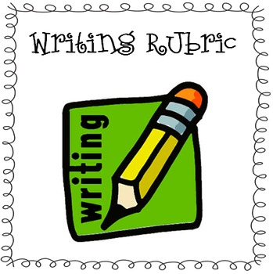
- Draft Two Then provide students with a rubric to use to modify their writing to shape their writing into a well organized essay or argument, presenting a case for an opinion on the topic

- As students revise their writing, new ideas on the topic may occur to them. The writer should further develop his or her new ideas, as these deepen insights into the topic.

- Draft Three The writer then rewrites the piece, revising the writing to keep the best ideas in the writing piece, and eliminate earlier thoughts that now are irrelevant to the topic or weaker ideas.

- Going back to the rubric, the writer now makes sure the writing piece fits the organization and other elements asked for by the rubric.

- Final copy editing. The writer re-reads the writing piece to correct spelling and punctuation.

- The writer reads the piece aloud to him or herself to make sure that the words sound correct for the thought, that an idea is clear, that punctuation is correct (periods at the end of a sentence when one pauses in writing, for example), apostrophes when a letter is missing or for ownership, etc.

- The writing is now ready for another reader to look at it!
A peer reads the writing piece, and puts a check mark where the writing:
- doesn’t make sense to the reader
- seems irrelevant or out of place in the piece
- lacks logic
- needs stronger, more appropriate, original, specific word choice
- needs imore appropriate introduction, transitions, conclusion
- save sentencing, punctuation or spelling errors for the final draft

- Draft Four The writer revises the writing in response to peer review comments. The writer again reviews the writing piece to ensure it presents the information or the case for the topic as well as possible, improving writing flow, organization, sentencing, word choice, and conventions (spelling and punctuation).

- Draft Four is now the final draft and goes to the teacher, who may find it acceptable or asks for revisions or corrections, final assessment

- The teacher reads aloud to the class best examples of student writing pieces, as models for the class to hear. Students note what they find best in the writing that’s anonymously read aloud.

