N Just-
spring when the world is mud-
luscious the little
lame baloonman
whistles far and wee

and eddieandbill come
running from marbles and
piracies and it's
spring

when the world is puddle-wonderful
the queer
old baloonman whistles
far and wee
and bettyandisbel come dancing
from hop-scotch and jump-rope and
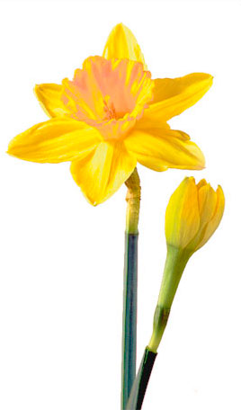
it's
spring
and
the
goat-footed
balloonMan whistles
far
and
wee
Close Reading: ~~~~~by: e e cummings (1894-1962)
Read the poem aloud twice (2 different readers)
- Inner circle: What is the central idea of this poem?
What words are evidence for this central idea?
What is the tone of this poem (sad, depressed, thoughtful, happy, wondering)
What words are evidence for this tone?
What is the point of view this is written from? What words are evidence of this point of view?
- Outer circle: Write down good ideas inner circle students make on this poem
Which speaker’s idea(s) in the circle gets a star for good thoughts on this poem? Why?
Open Response writing: What is the central idea in this poem and how do you know (evidence)?

