STAGE 1 – DESIRED RESULTS

Grade Level: 3rd Teacher’s name
Unit Title: Opinion Writing
Established Goals:

Using a Writer’s Workshop model, students will follow the writing process (plan, draft, revise/edit, and publish) to write an opinion piece that supports a clear point of view, includes an introduction to the topic, an opinion about the topic, and a clear organizational structure providing reasons for their opinion.

Understandings:  Students will understand the qualities of good opinion writing and utilize these techniques in their own writing. | Essential Questions:  *What does a writer need to do to clearly state his or her opinion?  *How does a writer persuade a reader to agree with his or her opinion?

Common Core Standards

CCSS.ELA-LITERACY.W.3.1
Write opinion pieces on topics or texts, supporting a point of view with reasons.
CCSS.ELA-LITERACY.W.3.1.A
Introduce the topic or text they are writing about, state an opinion, and create an organizational structure that lists reasons.
CCSS.ELA-LITERACY.W.3.1.B
Provide reasons that support the opinion.

STAGE 2 – ASSESSMENT EVIDENCE
Performance Tasks:  Students will write their own opinion pieces, conferencing with the teacher daily to assess their progress. A rubric will be used to assess the students’ writing. | Other Evidence:  Students will make a portfolio of their favorite opinion pieces.

STAGE 3 – LEARNING PLAN
Summary of Learning Activities:

- Students watch a BrainPop.com video about Fact vs. Opinion and take an online quiz about facts vs. opinions.
- Students sort various sentences into the categories “Fact” or “Opinion” (i.e. “Cats are really cute” and “Some cats are house pets.”)
- Students participate in a class activity to introduce opinion writing. Students are asked to tell their favorite type of candy. The results are tallied up and the two top candies are written on the board. Students split into two groups to come up with reasons about why their candy is the best, writing these reasons on a poster. Students then share their reasons with the class.
- Students are given multiple exemplars of good opinion writing and brainstorm strategies the author used to make their writing persuasive.
- Whole class discussion about what makes good opinion writing – ideas displayed on an anchor chart.
- Whole class discussion about the format of opinion writing (introduction, opinion, reasons for the opinion, conclusion).
- Students are given opinion writing with sentences mixed up and have to put the sentences in the correct order to gain familiarity with the format they should be using.
- Students write multiple examples of opinion writing, either coming up with topics on their own or responding to writing prompts provided.
- Work with the teacher and peers to edit and revise their writing.
- Publish their work by writing a final draft or typing a final draft on the computer.
- Make a portfolio of their favorite work.

Active Learning Strategies:

*Students spend the majority of their time engaged in writing tasks.
*Use of many model texts to engage students and discuss good opinion writing
*Use of teacher modeling with think alouds
*Students work in pairs to help revise their writing.

Differentiation:

*Use of structured graphic organizers for planning writing.
*Use of technology for students with difficulty writing (such as Dragon software on the iPad or word processors on the computer for students with O.T. difficulties)
*Pair lower level students with higher level students when editing/revising
*Use of a visual editing checklist when editing their work (see attached)
*Use of personal spelling dictionaries and word walls
*Use of sentence starters or word banks for lower level students

Reteach:

*The teacher will spend more conferencing time with struggling students or assign a classroom paraprofessional to assist struggling students during independent writing.
*The teacher will utilize independent writing time for small group, direct instruction for struggling students.
*The teacher will provide different graphic organizers and visual aides depending on the students’ level or area of struggle (i.e. are they struggling with structure and need an organizer or do they need more support with vocabulary and need a word bank?) (See here for examples of differentiated organizers: http://charmedinthirdgrade.blogspot.com/2011/11/differentiated-persuasive-graphic.html)

Rubric
to Guide and Assess Learning

I found this great, student-friendly rubric here: http://www.teacherspayteachers.com/Product/Common-Core-Writing-Rubrics-FREE-Grades-1-4-863723
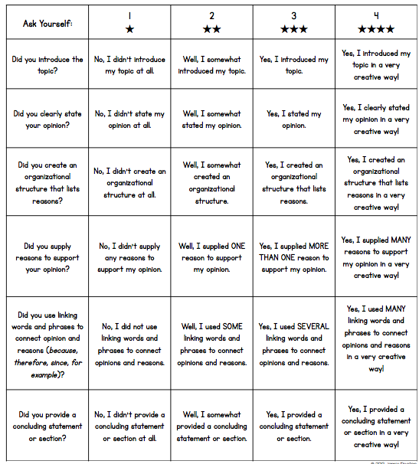
Editing Checklist

- Capitalization. Put a green box around the capital letters at the beginning of sentences.

- Punctuation. Put a red circle around the periods (.), question marks (?), or exclamation points (!) at the end of sentences.

- Spelling. Underline the words you think you need help with.

- Handwriting. Is your writing neat?

- Read out loud. Have someone read it to you. Does it make sense?

